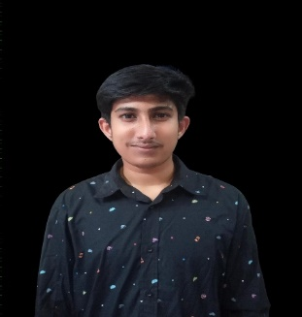**CURRICULUM VITAE**

**OF**

**SREE APURBO SARKER**

Malibag, 45,Siddessowri Dhaka-1712.

Cell: +8801324220899

**Career Objective:**

My Objective is to work in renowned organization where I can explore my potentiality. I have a desire to give my full effort in any sector. So that the organization can make maximum profit and that will help also facilitate to achieve my own goal.

**Academic Qualification :**

|  |  |  |  |  |  |
| --- | --- | --- | --- | --- | --- |
| **Name of Exam** | **Institution** | **Board** | **Group** | **Result** | **Passing Year** |
| HSC | Fakirhat Shahid Smriti Degree Colleg | Dinajpur | Humanitie | 4.50 | 2022 |
| SSC | Asutus Sarker School And College | Dinajpur | Science | 3.92 | 2020 |
| JSC | Asutus Sarker School And College | Dinajpur |  | 4.79 | 2017 |

**Capabilities**

→Energetic, hardworking and goal oriented.

→ Enjoy working under pressure.

→ Plan to start, organize lead and control.

**ICT Skills**

→ Operating Computer & Typewriter. ( MS Word, Excel, PowerPoint)

→ Good At Internet (Browsing, E-mail)

**Language Proficiency**

→ Bengali : As a mother tongue.

→ English : writing, reading, listening.

**Personal Details**

Name : Sree Apurbo Kumer Sarker

Father's Name : Sree Bidhan Chandra Sarker

Mother's Name : Sreemoti Golapy Rani Sarker

Permanent Address : Vill:Kumergari, P.O: Halimnagar,

P.S: Polasbari, Dist: Gaibandha.

Date of Birth : 20th December, 2004

Nationality : Bangladeshi (by birth)

Religion : Hindu

Sex : Male

Height : 6’

Marital Status : Unmarried

Blood Group : O+(ve)

National ID No : 7824571165

Signature

_____________

(Apurbo sarker)